Software Requirements Specification

For

Automated Record & Management System

Version 1.0 approved

##### **Prepared by**

##### **Capt Abdur Rehman Raza Khan**

##### **Cpl Zeeshan Mubarak**

##### **Gc Najeeb ur Rehman**

Military College of Signals

December 11, 2011

Table of Contents

Table of Contents ii

Introduction 1

1.1 Purpose 1

1.2 Scope 1

1.3 Definations, Abbreviations 1

1.4 References 2

1.5 Overview 2

2. Overall Description 2

2.1 Product Perspective 2

2.2 Product Functions 2

2.3 User Classes and Characteristics 3

2.4 Constraints 4

3. System Features 5

3.1 External Interfaces 7

3.2 Functions

3.2.1 Conrol Room Wirrless Operator USE Case 7

3.2.1.1 Request For Emergency Rescue 7

3.2.1.2 Additional Crew Request 7

3.2.2 Crew Manager USE Case 8

3.2.2.1 Assign Crew to Emergency 8

3.2.2.2 Assign Additional Crew 9

3.2.2.3 View Remarks 10

3.2.3 Crew Informer USE Case 10

3.2.3.1 Send Crew 10

3.2.3.2 Report Arrival Back 11

3.2.4 Station Incharge USE Case 11

3.2.4.1 View Emergency Handling Procedure 11

3.2.4.2 Report Generation 12

3.2.4.3 Remarks 12

3.2.5 Crew USE Case 13

3.3 Performance Reuirements 13

3.4 Logical Design Requirements 13

3.5 Design Constraints 14

3.6 Softwre System Quality Attributes 14

3.7 Object Oriented Model 15

4. External Interface Requirements 15

4.1 Annex A - User Interfaces 15

4.2 Annex B 19

4.2.1 Login 19

4.2.2 Submit 19

4.2.3 Update View 19

4.2.4 Search 20

4.2.5 Today's Emergencies 20

4.2.6 Recent Emergencies 20

4.2.7 Status Of Crew 21

4.2 Annex C - ER Diagram 22

4.3 Annex D - Class Diagram 23

4.4 Annex E - Activity Diagram Interfaces 24

# Introduction

## Purpose

The purpose of this document is to present a detailed description of Automated Record & Management System for the Rescue 1122. It will explain the purpose and features of the system, the interfaces of the system, what the system will do, the constraints under which it must operate. Document is intended for developers, project managers, users, software test engineers.

## Project Scope

The Automated Record & Management System is designed for efficient handling of the available crew and providing staff the information of activity currently in progress. The product provide

* Automated Records
* Crew Management
* Quick Response to emergency request
* Status of Emergency & Crews
* Reports Generation
* Central Authentication
* LAN Connectivity

## Definitions. Acronyms, and Abbreviations

* **ARMS** – Automated Record & Management System
* **CRWO** – Control Room Wireless Operator
* **SI** – Station Incharge
* **MO** – Medical Officer
* **CI** – Crew Informer

## Reference

* <http://wilma.vub.ac.be/~se4_2006/documents/SRS/srs/node1.html>
  + For SRS Pattern and Guideline
* <http://www.softwarearchitectures.com/go/Discipline/DesigningArchitecture/QualityAttributes/tabid/64/Default.aspx>
  + Software Quality Attributes
* <http://stackoverflow.com/questions/2231658/what-is-a-logical-requirement>
  + Logical Database Requirements
* <http://www.smartdraw.com/resources/tutorials/entity-relationship-diagrams/>
  + ER - Diagram

## Overview

The 1st section of the document describes the purpose, scope of the project and various abbreviations used in this document. The 2nd section gives the product high level functionalities, identifies the user classes and different constrains imposed. The 3rd section deals with each use case in detail. It contains logical database requirements and object oriented model including activity diagrams.

# Overall Description

## Product Perspective

The ARMS is a replacement of existing system. The existing system maintains the data on registers and all the staff within offices has to inform each other through telephone or personally about some emergency. The product will enable the staff i.e (Control Room Wireless Operator, Crew Manager, Station Incharge) to remain in picture what activity is going on and provide better management of crew. The response time to the emergency will decrease which will ultimately benefit the general public.

## Product Functions

Following are product main Functions:-

* Data Management
  + Initial info record
  + Detailed Emergency Report
  + Remarks of Station Incharge
* Crew Management
* Status of Emergency
* Status of Crew
* Report Generation
* Search

## User Classes and Characteristics

* Control Room Wireless Operator
  + It receives the phone calls for emergency and fills the initial emergency request form. Generally Two types of Calls
    - Request for Emergency
    - Request for Additional Crew
* Crew Manager
  + When an initial request form is filled, Crew manager assigns the crew based on nature of emergency.
* Crew Informer
  + When some crew is assigned for some emergency dealing, it sends them to the location of emergency. And fills out the time of leaving the garage and time of reporting back from the emergency.
* Station Incharge
  + It is overall supervisor of a rescue 1122 station. He manages the reports and supervises all the staff.
* Crew
  + Crew deals with emergency physically by going on location. On completion, crew fills out detailed report about the emergency. Crew consists of
    - Medical Officer(MO)
    - Rescue 1122 Staff(driver, helper, rescuer)
    - Nursing Staff

## Constraints

|  |  |
| --- | --- |
| .  **Constraints** | **Rationale** |
| * Microsoft Windows | * The users have prior experience of using this operating system. |
| * The system coding will be done in C# language with object-oriented methodology. | * C# is a powerful high level language by Microsoft. Support of large .Net Library enhances its capability and makes it suitable for Desktop software. |
| * Microsoft SQL Server | * It is professionally being used worldwide. Its integration with Windows OS is easy and stable. It provides efficient and reliable database operation and accommodates fairly large numbers of records. |
| * LAN | * Since all the users of the system reside in one building and all the data is to be maintained on one central database |

# Specific Recuirements

CRWO

Crew Manager

ARMS

CI

View

Crew

Request Handler

SI

Database

The system will be made using Model-View-Controller approach. All the Users initiate request for the desired operation. The request handler entertains the request and performs required operation after authentication. Request handler inserts, deletes, updates entries from database and provide appropriate data/Form to view so that users can see result/initiate further Action.

## External Interfaces

User Interfaces of ARMS are as per Annex A.

## Functions

### Control Room Wireless Operator USE Case

**3.2.1.1 Request For Emergency Rescue**

**Brief Description**

The Control Room Wireless Operator on receiving the call of new emergency fills out initial information.

**Initial Step-By-Step Description**

Before this use case can be initiated, the CRWO has to be logged in as CRWO so that he can get associated interface to fill initial information.

1. The CRWO on receiving the call click on new emergency button
2. The System gives initial information form.
3. The CRWO fills the form and click on submit.
4. The Request handler insert the data into database.
5. On completion, Successful insertion message is displayed
6. The CRWO is returned to main page.

**Xref:** Section 4.2.1, Submit

**3.2.1.2 Additional Crew Request**

**Brief Description**

The Control Room Wireless Operator on receiving the call for additional crew initiate the request.

**Initial Step-By-Step Description**

Before this use case can be initiated, the CRWO has to be logged in as CRWO so that he can get associated interface.

1. The CRWO on receiving the call click on Additional Crew Request Button.
2. The System provides the list of in progress emergencies.
3. The CRWO selects the emergency for which additional crew request was asked.
4. The System provides the view which shows the details of staff already sent for that emergency.
5. The CRWO writes the detail of additional requested crew.
6. The CRWO submit the details.
7. The Request Handler modifies the record of that particular emergency.
8. On completion, Successful insertion message is displayed.
9. The CRWO is returned to main page.

**Xref:** Section 4.2.1, Submit

### Crew Manager USE Case

**3.2.2.1 Assign Crew to Emergency**

**Brief Description**

When so ever the new Emergency form is submitted by the CRWO Crew Manager Assigns the crew to emergency based upon the nature of emergency.

**Initial Step-By-Step Description**

Before this use case can be initiated, the CREW manager has to be logged in as Crew Manager so that he can get associated interface.

1. The System provides the crew manager with a blank interface.
2. When so ever the CRWO submit the request for crew, the view is updated and detail of emergency is provided.
3. Crew Manager reads the details and assign the crew from list of available crew
4. On completion, Successful message is displayed
5. In case no crew is free, Crew Manager is provided with the list of all the crews and their nature of emergency.
6. Then Crew manager assigns the crew which is expected to fall back soon.
7. The crew manger is returned to main page.
8. Request Handler keep track of assigning of crew. If the assigned crew doesn’t come back soon and some other crew has returned, crew manager is alerted so that he can reassign the crew.

**Xref:** Section 4.2.1, Submit, 4.2.2 Update view

**3.2.2.2 Additional Crew Request**

**Brief Description**

When so ever the request for additional crew is submitted by the CRWO, Crew Manager Assigns the crew.

**Initial Step-By-Step Description**

Before this use case can be initiated, the CREW manager has to be logged in as Crew Manager so that he can get associated interface.

1. The System provides the crew manager with a blank interface.
2. When so ever the CRWO submit the request for additional crew, the view is updated and detail of emergency is provided.
3. Crew Manager reads the details and assign the crew from list of available crew
4. On completion, Successful message is displayed
5. In case no crew is free, Crew Manager is provided with the list of all the crews and their nature of emergency.
6. Then Crew manager assigns the crew which is expected to fall back soon.
7. The crew manger is returned to main page.
8. Request Handler keep track of assigning of crew. If the assigned crew doesn’t come back soon and some other crew has returned, crew manager is alerted so that he can reassign the crew.
9. The CRWO is returned to main page.

**Xref:** Section 4.2.1, Submit, 4.2.2 Update view

**3.2.2.3 View Remarks**

**Brief Description**

When emergency is Completed, SI writes the remarks about the emergency handling procedure.

**Initial Step-By-Step Description**

Before this use case can be initiated, the CREW manager has to be logged in as Crew Manager so that he can get associated interface.

1. The System provides the crew manager with the list of today’s emergencies.
2. If SI writes remarks on some emergency, the view is updated
3. Crew Manager selects the emergency and click it to view remarks
4. Remarks are shown
5. Emergency is marked as read.

**Xref:** Section 4.2.1, Submit, 4.2.2 Update view

### Crew Informer Use Case

**3.2.3.1 Send Crew**

**Brief Description**

When so ever a Crew is assigned to some emergency, crew informer sends the crew to location.

**Initial Step-By-Step Description**

Before this use case can be initiated, the Crew informer has to be logged in as Crew Manager so that he can get associated interface.

1. The System provides the crew informer with interface which contains list of all the crews.
2. When so ever some crew is assigned, the crew informer view is updated.
3. Crew informer reads out the details and sends the crew to location.
4. Crew informer fills in the time for departure and submit.
5. On completion, Successful message is displayed

**Xref:** Section 4.2.1, Submit, 4.2.2 Update view

**3.2.3.2 Report Arrival Back**

**Brief Description**

When so ever a Crew is back from some emergency, crew informer fills the arrival back time.

**Initial Step-By-Step Description**

Before this use case can be initiated, the Crew informer has to be logged in as Crew Manager so that he can get associated interface.

1. The System provides the crew informer with interface which contains the list of all the crews.
2. When so ever some crew is back, the crew informer fills the report back time
3. Crew informer submits the data
4. On completion, Successful message is displayed

**Xref:** Section 4.2.1, Submit, 4.2.2 Update view

### Station Incharge USE Case

**3.2.4.1 View Emergency Handling Procedure**

**Brief Description**

Station Incharge views the emergency handling procedure to keep check on performance.

**Initial Step-By-Step Description**

Before this use case can be initiated, the Station Incharge has to be logged in as Station Incharge so that he can get associated interface.

1. The System provides the Station Incharge request for emergency procedure view.
2. The System Provides list of current date all completed Emergencies and a search box to search back date events.
3. Station incharge clicks on some current date emergency or search for some back date.
4. Station Incharge is provided with a view of details of the emergency handling.
5. On clicking back page Button Station Incharge return to his main page.

**Xref:** Section 4.2.1, Submit, 4.2.2 Update view

**3.2.4.2 Report Generation**

**Brief Description**

Station Incharge views the emergency handling procedure to write report about it.

**Initial Step-By-Step Description**

Before this use case can be initiated, the Station Incharge has to be logged in as Station Incharge and view some emergency handling procedure.

1. After viewing emergency handling Procedure, SI click on Write Report Button
2. SI is provided with report writing view.
3. SI writes the report and submit it.
4. On submission Station Incharge return to his main page.

**Xref:** Section 4.2.1, Submit, 4.2.2 Update view

**3.2.4.3 Remarks**

**Brief Description**

Station Incharge views the emergency handling procedure to write his observations and remarks about the procedure adopted.

**Initial Step-By-Step Description**

Before this use case can be initiated, the Station Incharge has to be logged in as Station Incharge and view some emergency handling procedure.

1. After viewing emergency handling Procedure, SI click on Write Remarks Button
2. SI is provided with remarks writing view.
3. SI writes the remarks and observations and submit it.
4. On submission Station Incharge return to his main page.

**Xref:** Section 4.2.1, Submit, 4.2.2 Update view

### Crew Use Case

**Brief Description**

On coming back from emergency, the crew leader needs to report back the details of emergency handling procedure, medical aid provided, store used.

**Initial Step-By-Step Description**

Before this use case can be initiated, the Crew has to be logged in so that appropriate view can be provided.

1. Crew Leader is provided with the list of all emergences he has handled and yet not written the detailed report.
2. Crew Leader writes the report and submit it.
3. On submission Crew Leader is returned to his main page.

**Xref:** Section 4.2.1, Submit, 4.2.2 Update view

## Performance Requirements

* The System shall be ready to use within 5 seconds of the launch.
* The System shall complete search in 1000 records within 2 seconds.
* The System shall update user view within 2 seconds of data change in database.
* The system shall generate an error message if connection to database fails prolong more than 10 seconds.
* Statistical Report generation shall take less than 15 seconds for 98% of the cases.

## Logical Database Requirements

The ER – Diagram is attached as Annex C.

## Design Constraints – Standards Compliance

* The communication between UI and database shall be by SQL query.
* Transfer of Data shall be over TCP stream.
* The source code must follow coding conventions
* Update operation shall be a stored procedure

## Software System Quality Attributes

* **Reliability**. No more than 1 per 10000 update shall result in a failure requiring a system restart.
* **Robustness**. The system shall restart and start functioning within 15 seconds after crash
* **Availability**. The system shall not be unavailable more than 10 minutes for 100 hour of operation.
* **Security**. After 3 simultaneous login attempts with wrong password, system shall stop responding for 5 mins.
* **Learning.** After two hour training session, Number of errors shall not exceed 3 per week.
* **Maintainability.** Installation of new version/Reinstallation shall leave database unchanged.

## Object Oriented Model

Class Diagram, Activity Diagram are Attached as Annex – D, E repectively.

# Appendices

## Appendix A: User Interface

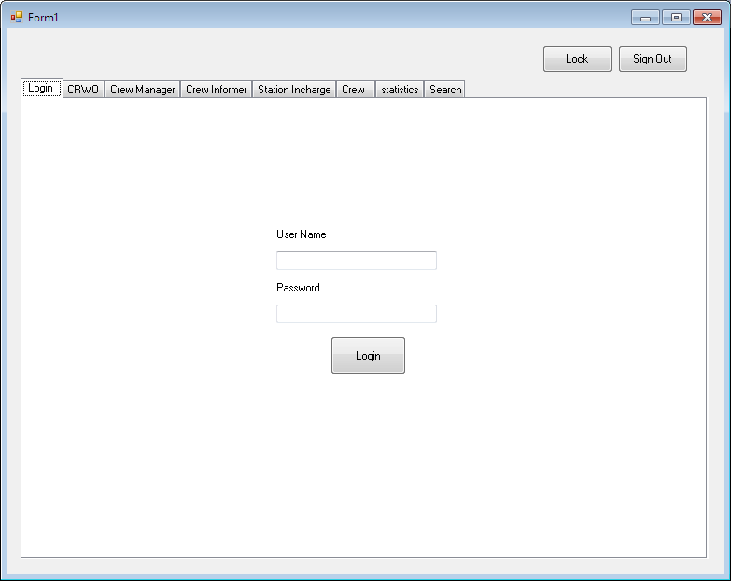

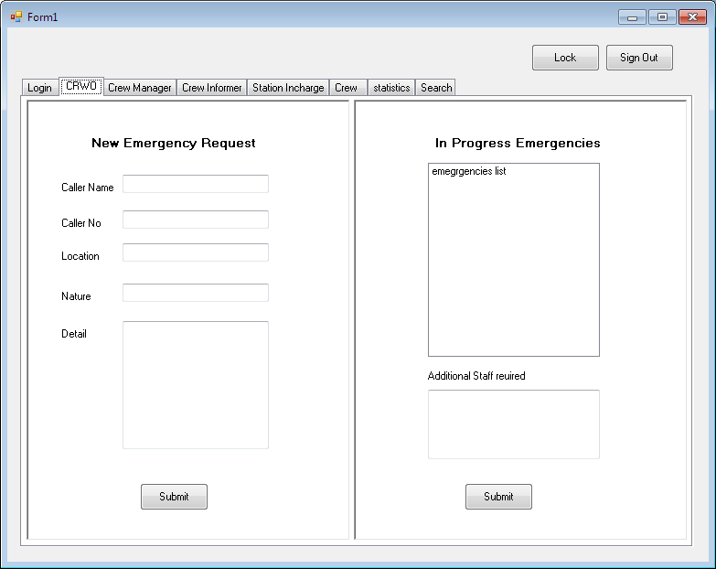

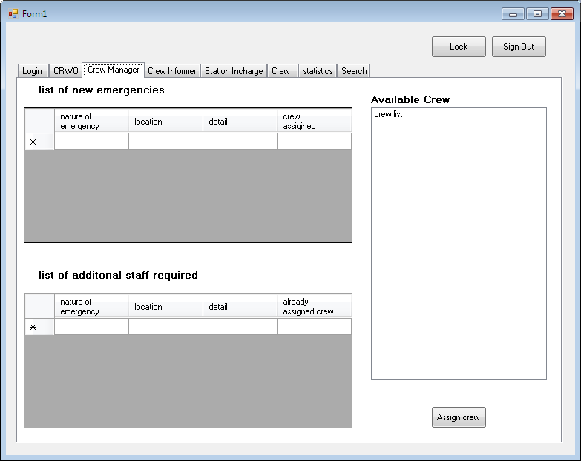

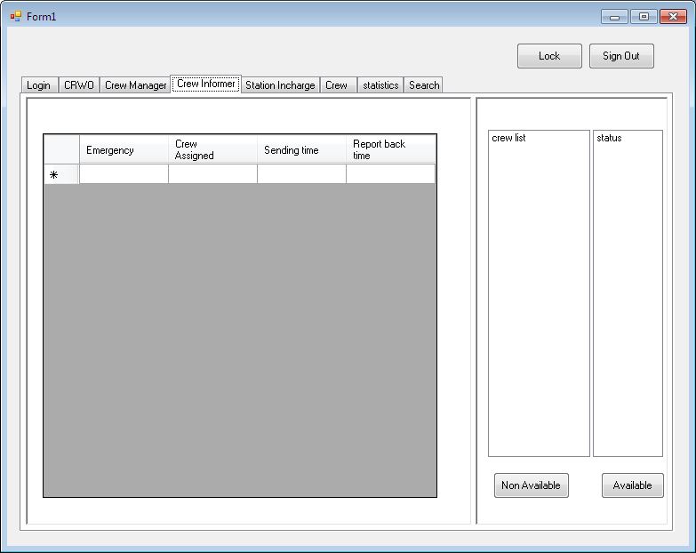

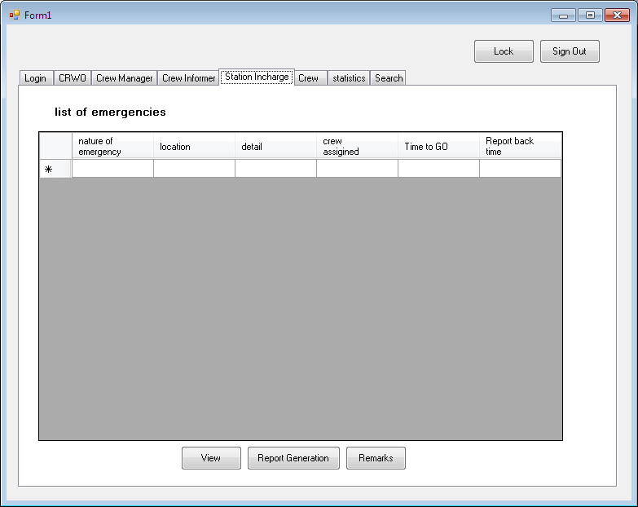

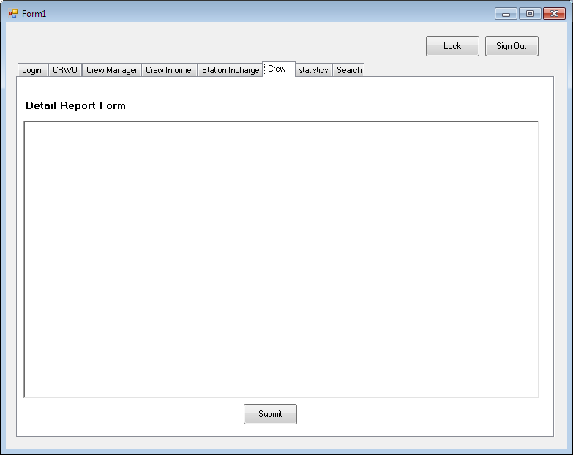

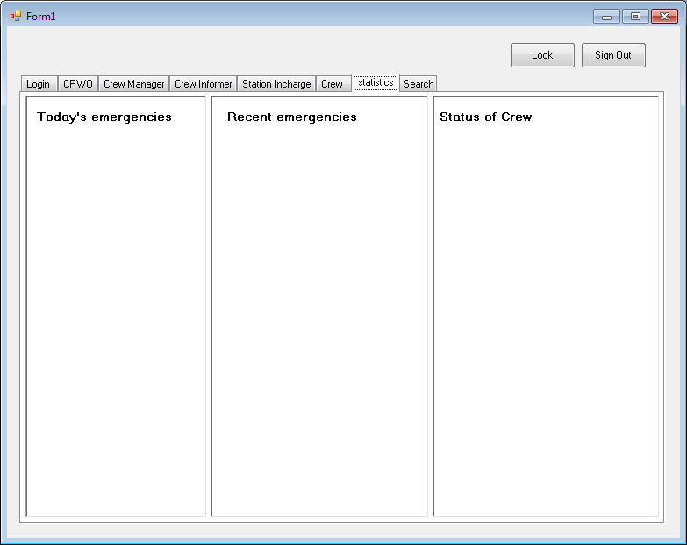

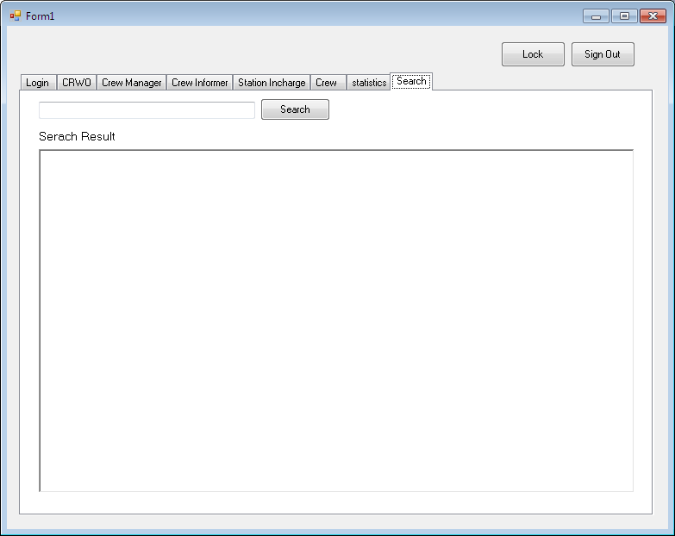

## Appendix B - Software Use Cases

**4.2.1 Login**

|  |  |
| --- | --- |
| **Use Case Name** | Login |
| **XRef** | On Sign Out/Start of Application |
| **Trigger** | When users hit Log In Button |
| **Precondition** | 1. The Product must have load correctly 2. Connection to Database Established |
| **Basic Path** | 1. Represents login info view 2. On Click, check username and password in database 3. Allow access to appropriate tab view according to logged in user |
| **Alternative Paths** | If login failed due to wrong password, show message box |
| **Postcondition** | On Successful login, show associated tab |
| **Exception Paths** | On connection failure, show message |
| **Other** | Nill |

**4.2.2 Submit**

|  |  |
| --- | --- |
| **Use Case Name** | Submit |
| **XRef** | 3.1,3.2,3.3,3.4,3.5,3.6 |
| **Trigger** | When Users Click Submit Button |
| **Precondition** | 1. The User must be logged in |
| **Basic Path** | 1. Checks the Data for Integrity  2. Write the Data to Database |
| **Alternative Paths** | In case of Wrong data Show Error Message |
| **Postcondition** | On Completion take back to main page |
| **Exception Paths** | On connection failure, show message |
| **Other** | Nill |

**4.2.3 Update View**

|  |  |
| --- | --- |
| **Use Case Name** | Update View |
| **XRef** | 3.1,3.2,3.3,3.4,3.5,3.6 |
| **Trigger** | When so ever some modification to Database is made |
| **Precondition** | The User must be logged in |
| **Basic Path** | 1. Checks for the Required data in Database for the logged in user  2. Update the view |
| **Alternative Paths** | Nill |
| **Postcondition** | Connection to Database must be established |
| **Exception Paths** | On connection failure, show message |
| **Other** | Nill |

**4.2.4 Search**

|  |  |
| --- | --- |
| **Use Case Name** | Search |
| **XRef** | 3.1,3.2,3.3,3.4,3.5,3.6 |
| **Trigger** | When search button is clicked |
| **Precondition** | The User must be logged in |
| **Basic Path** | 1. Checks for the Required data in Database  2. Update the view |
| **Alternative Paths** | Show Message if no record Found |
| **Postcondition** | Connection to Database must be established |
| **Exception Paths** | On connection failure, show message |
| **Other** | Nill |

**4.2.5 Today’s Emergencies**

|  |  |
| --- | --- |
| **Use Case Name** | Today’s Emergencies |
| **XRef** | 3.1,3.2,3.3,3.4,3.5,3.6 |
| **Trigger** | When Statistics tab is clicked |
| **Precondition** | The User must be logged in |
| **Basic Path** | 1. Checks for the Current date’s emergencies data in Database  2. Update the view |
| **Alternative Paths** | Show Message if no record Found |
| **Postcondition** | Connection to Database must be established |
| **Exception Paths** | On connection failure, show message |
| **Other** | Nill |

**4.2.6 Recent Emergencies**

|  |  |
| --- | --- |
| **Use Case Name** | Recent Emergencies |
| **XRef** | 3.1,3.2,3.3,3.4,3.5,3.6 |
| **Trigger** | When Statistics tab is clicked |
| **Precondition** | The User must be logged in |
| **Basic Path** | 1. Checks for the recent emergencies data in Database  2. Update the view |
| **Alternative Paths** | Show Message if no record Found |
| **Postcondition** | Connection to Database must be established |
| **Exception Paths** | On connection failure, show message |
| **Other** | Nill |

**4.2.7 Status Of Crew**

|  |  |
| --- | --- |
| **Use Case Name** | Today’s Emergencies |
| **XRef** | 3.1,3.2,3.3,3.4,3.5,3.6 |
| **Trigger** | When Statistics tab is clicked |
| **Precondition** | The User must be logged in |
| **Basic Path** | 1. Checks for the data of all the crews in Database and shows their activity record  2. Update the view |
| **Alternative Paths** | Show Message if no record Found |
| **Postcondition** | Connection to Database must be established |
| **Exception Paths** | On connection failure, show message |
| **Other** | Nill |

## Appendix C – ER Diagram

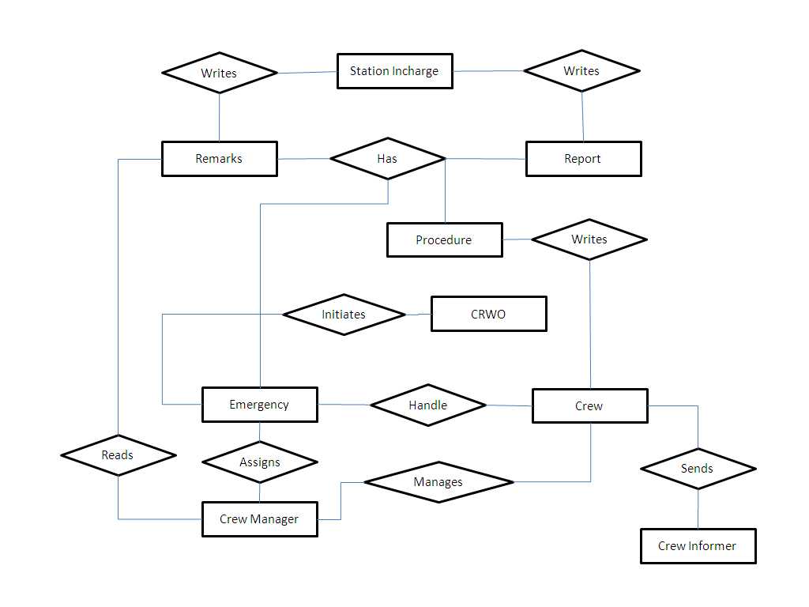

## Appendix D – Class Diagram

## Appendix E – Activity Diagrams